DECODING ROC-AUC CURVE
Introduction:
In recent years, Machine learning has taken the world to another level of easiness, it has never seen before, and still, it’s only the start. It has been a prominent subject of study for the scientists and Engineers. Learning concepts and algorithms is essential in Machine Learning and in this blog, we will be covering an important one of it.
So, in the domain of machine learning and predictive modelling, the Receiver Operating Characteristic (ROC) curve and the Area Under the Curve (AUC) are pivotal tools for evaluating the performance of classification models. This blog aims to provide a deep understanding of the ROC-AUC curve, its significance, interpretation, and practical applications through various real-life examples.
Basics:
Before digging deep into the topic of ROC-AUC curve, let’s just revise with some concepts which are essential for ROC-AUC Curve. But still I suggest you to go through the concept of confusion matrix and all the classification metrics deeply before reading this blog.
- Confusion Matrix: A Confusion matrix is an N x N matrix used for evaluating the performance of a classification model, where N is the number of target classes.
This is what it looks like:
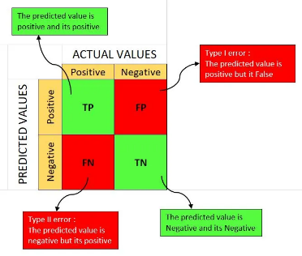
- Specificity (True Negative Rate): Proportion of actual negatives correctly identified by the model.
Specificity = Correctly identified negatives / Total actual negatives
= TN / (TN + FP)
- Sensitivity (True Positive Rate): Proportion of actual positives correctly identified by the model.
Sensitivity = Correctly identified positives / Total actual positives
= TP / (TP + FN)

Understanding ROC and AUC:
The ROC Curve evaluates the performance of a classification model at different thresholds. It plots the True Positive Rate I.e. Sensitivity (on y-axis) against the False Positive Rate i.e. 1 – Specificity (on x-axis). While AUC or Area Under the Curve is the area under the ROC Curve indicates a model’s overall performance. Higher AUC values signify better performance.
Interpreting the ROC Curve:
The ROC curve is a valuable diagnostic tool, enabling practitioners to assess a model's trade-off between sensitivity and specificity across various threshold values. A perfect model would have an ROC curve that reaches the top-left corner, representing a TPR of 1 and an FPR of 0. Conversely, a purely random classifier's ROC curve would be a diagonal line from the bottom-left to the top-right. Deviations from this diagonal line indicate a model's discriminatory power.
The best option of (FPR, TPR) will lead to the best value of threshold. Now, this ‘best option’ changes with change in problem or model. If the model needs more accuracy and less false rate (like in health-related data), then we will choose the one with high TPR and less FPR. And so, on depending on the cases you develop your model, you choose your best option.

How ROC Work?
Let’s see the step-by-step process of how the ROC Curve is formed.
- ROC Curve has X-axis as False Positive Rate (1 – Specificity) and y-axis as True Positive Rate (Sensitivity).
- For different values of threshold varying between 0 and 1, the model predicts the target value (y_pred).
- Then as the model predicts the target value, and as we already have the actual target value (y_test), we use these two parameters and form a confusion matrix.
- From the confusion matrix, we get FPR and TPR from the formulas discussed above.
And then plot (FPR, TPR) as (x, y) on the curve.
- This is done for different threshold values and with each we get (FPR, TPR), which indeed is a point on the ROC Curve.

Significance of AUC:
The AUC serves as a pivotal metric for comparing different models and assessing their overall performance. It provides a single-value summary of a model's discriminative power, independent of the specific threshold chosen. Models with higher AUC values are generally considered more effective at distinguishing between classes, making the AUC an indispensable measure when comparing and selecting classification models.
The Area Under the Curve (AUC) quantifies the overall performance of a classification model. It measures the entire two-dimensional area underneath the ROC curve from (0,0) to (1,1).
Interpretation of AUC Values (0 to 1)
AUC values range from 0 to 1:
- 0.5: No discrimination (random guessing).
- 0.7 - 0.8: Acceptable performance.
- 0.8 - 0.9: Excellent performance.
- Above 0.9: Outstanding performance.
Significance of the Diagonal Line
The diagonal line on the ROC curve represents the chance level:
- Above the Line: The model performs better than random guessing.
- Below the Line: The model is worse than random; adjustments are needed.

Let’s Understand it with the Curve:
The higher the AUC, the better the model’s performance.
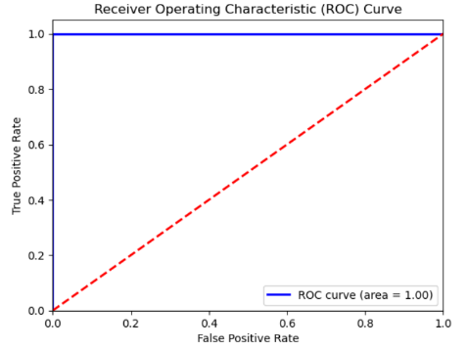
In this case, it is equal to 1 i.e. maximum value of AUC, which means that the model can correctly distinguish between the positive class and negative class.
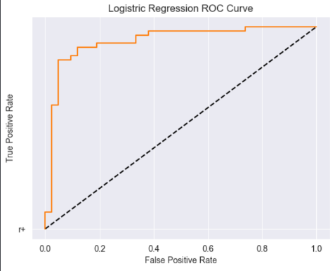
In this case, 0.5 < AUC < 1 i.e. the classifier is able to distinguish between the positive and negative classes correctly but on some instant, it is getting wrong. Since, AUC value is greater than 0.5, it is clearly predicting a greater number of true positives and true negatives correctly.
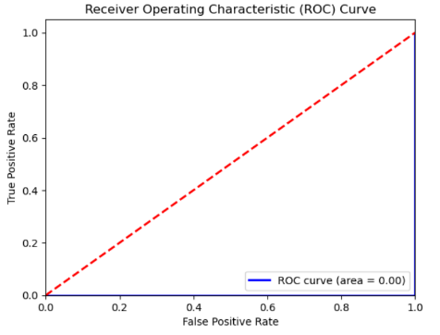
Now, in this case the AUC = 0, i.e. the classifier has predicted all positives as negatives and vice-versa.

Let’s Dive into the coding part now…
- Firstly, we import the basic libraries
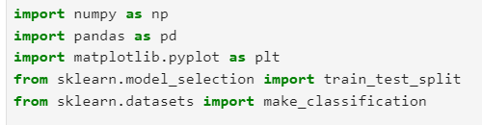
- Then, create a random small dataset and then split into training and testing dataset.
- Now, we fit the models with their respective classifiers and predicts the value on X_test.
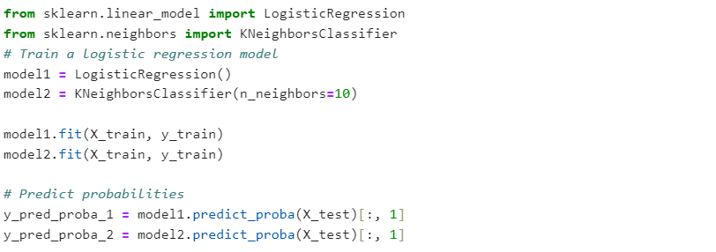
- After, predicting the target values, we use the roc_curve library to fit the FPR and TPR, from the parameters y_test and y_pred_proba. The roc_curve library forms the confusion matrix for different threshold values and returns the FPR and TPR.
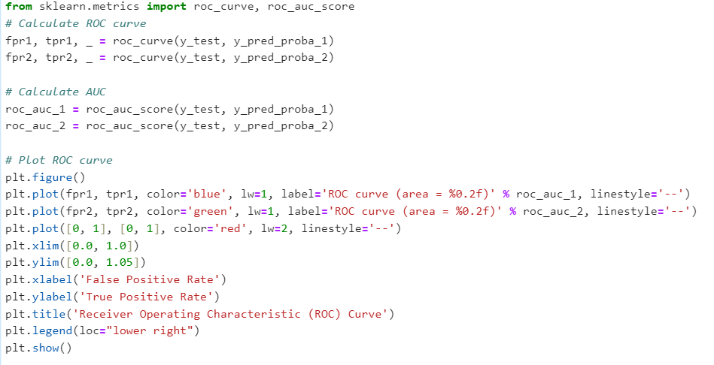
Here’s the look of the ROC Curve –
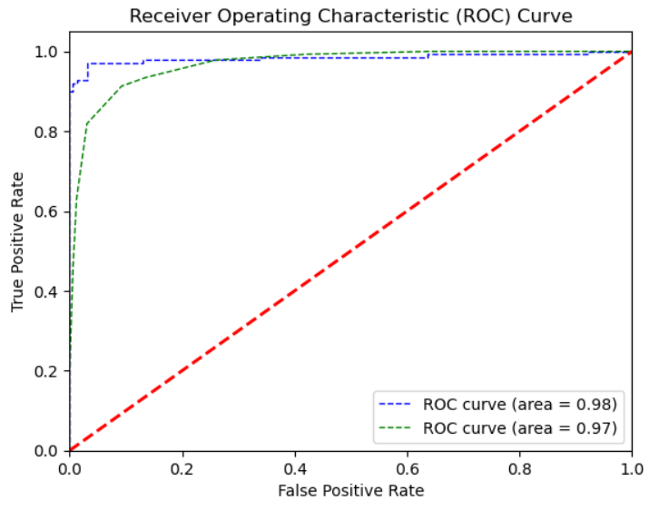

Real-World Use Cases in Various Industries:
- Healthcare and Medical Diagnostics: In medical diagnostics, ROC-AUC is crucial. For instance, a model predicting the likelihood of diabetes needs to distinguish between patients who have the disease and those who do not, making ROC-AUC vital for evaluating its effectiveness.
- Finance for Credit Scoring Models: Assessing the likelihood of loan defaults.
- Role in Marketing Analytics: Determining the effectiveness of campaigns.

Challenges and Limitations of ROC-AUC:
- Situations Where ROC-AUC May Be Misleading
In some contexts, such as highly imbalanced datasets, ROC-AUC might not tell the whole story. Other measures may also need consideration.
- Limitations Related to Imbalanced Datasets
AUC can be biased toward the majority class, potentially masking poor performance on minority instances.
- Alternatives to ROC-AUC for Specific Scenarios (Like Precision-Recall Curves)
Consider using additional metrics such as precision-recall curves for a more nuanced evaluation.

Conclusion:
As machine learning and predictive modelling continue to advance, the significance of the ROC-AUC curve endures, empowering practitioners to gauge the effectiveness of classification models and drive impactful decision-making across an array of domains.
With a solid understanding of the ROC-AUC curve, you can effectively evaluate model performance across various fields. Continual learning and application of these methods are essential for making informed decisions that can lead to better outcomes in real-world scenarios.
FREQUENTLY ASKED QUESTIONS (FAQs)
What does a higher AUC value indicate?
A higher AUC value indicates better model performance in distinguishing between positive and negative classes.
Can the ROC curve be used for multi-class classification?
Yes, ROC curves can be adapted for multi-class scenarios using one-vs-all or one-vs-one approaches.
Why is AUC not the only metric to consider in model evaluation?
AUC provides a good overview, but metrics like precision and recall may give deeper insights, especially in imbalanced classes.
How do I interpret a ROC curve that crosses the diagonal line?
A curve that crosses the diagonal suggests a model that may not perform much better than random guessing; further tuning may be needed.
What are typical pitfalls when interpreting ROC curves?
Common pitfalls include misunderstanding data leakage, not considering the impact of class imbalance, and failing to use cross-validation for robust analysis.

